Irrational Numbers Set
# Source: AI Source: Provided by: [Data Path: Persons Table -> ID Column: 1, Name_En Column: Motasem Essam] -> From: [ChatGPT] on [7/15/2026]
The Irrational Numbers Set is the set of all real numbers that cannot be expressed as the quotient (fraction) of two integers. Their decimal expansions are infinite, non-terminating, and non-repeating.
Irrational numbers are fundamental to algebra, geometry, trigonometry, calculus, number theory, engineering, physics, computer science, and many other branches of mathematics.

Definition
# Source: AI Source: Provided by: [Data Path: Persons Table -> ID Column: 1, Name_En Column: Motasem Essam] -> From: [ChatGPT] on [7/15/2026]
The Irrational Numbers Set consists of all real numbers that cannot be written in the form
$$\frac{a}{b},$$
where
- $a$and $b$are integers, and
- $b≠0$.
Unlike rational numbers, irrational numbers cannot be represented exactly as a fraction of two integers.

Symbol
# Source: AI Source: Provided by: [Data Path: Persons Table -> ID Column: 1, Name_En Column: Motasem Essam] -> From: [ChatGPT] on [7/15/2026]
There is no universally accepted standard symbol for the set of irrational numbers.
It is most precisely defined as
$$\boxed{R∖Q}$$
meaning
Real Numbers minus Rational Numbers.
Some educational texts use
$$I$$
for irrational numbers, but this notation is informal and not universally standardized.

Set Notation
# Source: AI Source: Provided by: [Data Path: Persons Table -> ID Column: 1, Name_En Column: Motasem Essam] -> From: [ChatGPT] on [7/15/2026]
Set-Builder Notation
$$\boxed{R-Q=\left\{x∈R:x∉Q\right\}}$$
This means
"The set of all real numbers that are not rational."

Examples
# Source: AI Source: Provided by: [Data Path: Persons Table -> ID Column: 1, Name_En Column: Motasem Essam] -> From: [ChatGPT] on [7/15/2026]
Common irrational numbers include
$$π, e, \sqrt{2}, \sqrt{3}, \sqrt{5}, ϕ$$
where
$$ϕ=\frac{1+\sqrt{5}}{2}$$
is the Golden Ratio.

Decimal Representation
# Source: AI Source: Provided by: [Data Path: Persons Table -> ID Column: 1, Name_En Column: Motasem Essam] -> From: [ChatGPT] on [7/15/2026]
Every irrational number has a decimal expansion that is
- Infinite
- Non-terminating
- Non-repeating
Examples:
$$π=3.14159265358979… \\ \sqrt{2}=1.41421356237309… \\ e=2.71828182845904…$$
No repeating pattern exists.

Non-Examples
# Source: AI Source: Provided by: [Data Path: Persons Table -> ID Column: 1, Name_En Column: Motasem Essam] -> From: [ChatGPT] on [7/15/2026]
The following are not irrational numbers:
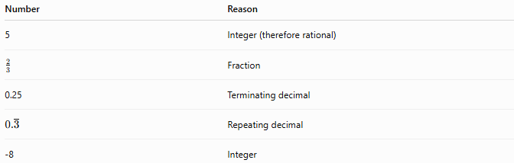
Number | Reason
5 | Integer (therefore rational)
$$\frac{2}{3}$$ | Fraction
0.25 | Terminating decimal
$$0.\overset{‾}{3}$$ | Repeating decimal
-8 | Integer

Categories of Irrational Numbers

Square Roots of Non-Perfect Squares
# Source: AI Source: Provided by: [Data Path: Persons Table -> ID Column: 1, Name_En Column: Motasem Essam] -> From: [ChatGPT] on [7/15/2026]
Examples:
$$\sqrt{2}, \sqrt{3}, \sqrt{5}, \sqrt{7}$$

Cube Roots of Most Non-Perfect Cubes
# Source: AI Source: Provided by: [Data Path: Persons Table -> ID Column: 1, Name_En Column: Motasem Essam] -> From: [ChatGPT] on [7/15/2026]
Examples:
$$\sqrt[3]{2}, \sqrt[3]{5}$$

Mathematical Constants
# Source: AI Source: Provided by: [Data Path: Persons Table -> ID Column: 1, Name_En Column: Motasem Essam] -> From: [ChatGPT] on [7/15/2026]
Examples:
$$π, e, ϕ$$

Many Trigonometric Values
# Source: AI Source: Provided by: [Data Path: Persons Table -> ID Column: 1, Name_En Column: Motasem Essam] -> From: [ChatGPT] on [7/15/2026]
Examples:
$$sin⁡1, cos⁡1$$
(where the angle is measured in radians).

Characteristics
# Source: AI Source: Provided by: [Data Path: Persons Table -> ID Column: 1, Name_En Column: Motasem Essam] -> From: [ChatGPT] on [7/15/2026]
Irrational numbers:
- Cannot be written as fractions.
- Have infinite decimal expansions.
- Never terminate.
- Never repeat.
- Form an infinite set.
- Are dense on the number line.
Between any two irrational numbers there is another irrational number.

Properties
# Source: AI Source: Provided by: [Data Path: Persons Table -> ID Column: 1, Name_En Column: Motasem Essam] -> From: [ChatGPT] on [7/15/2026]
Irrational numbers are not closed under all arithmetic operations.
Examples:
Addition
$$\sqrt{2}+\sqrt{3}$$
is irrational.
However,
$$\sqrt{2}+(-\sqrt{2})=0$$
is rational.

Multiplication
$$\sqrt{2}×\sqrt{3}=\sqrt{6}$$
is irrational.
However,
$$\sqrt{2}×\sqrt{2}=2$$
is rational.

Division
$$\frac{\sqrt{2}}{\sqrt{3}}$$
is irrational.
However,
$$\frac{\sqrt{2}}{\sqrt{2}}=1$$
is rational.

Relationship to Other Number Sets
# Source: AI Source: Provided by: [Data Path: Persons Table -> ID Column: 1, Name_En Column: Motasem Essam] -> From: [ChatGPT] on [7/15/2026]
$$\boxed{R=Q∪(R-Q)}$$
and
$$\boxed{Q∩(R-Q)=∅}$$
This means
- Every real number is either rational or irrational.
- No number is both rational and irrational.

Examples
# Source: AI Source: Provided by: [Data Path: Persons Table -> ID Column: 1, Name_En Column: Motasem Essam] -> From: [ChatGPT] on [7/15/2026]
Example 1
Determine whether
$$\sqrt{2}$$
is irrational.
Yes.

Example 2
Determine whether
$$π$$
is irrational.
Yes.

Example 3
Determine whether
$$\frac{5}{7}$$
is irrational.
No.
It is rational.

Example 4
Determine whether
$$0.125$$
is irrational.
No.
It is a terminating decimal.

Example 5
Determine whether
$$0.\overset{‾}{9}$$
is irrational.
No.
Repeating decimals are rational.

Applications
# Source: AI Source: Provided by: [Data Path: Persons Table -> ID Column: 1, Name_En Column: Motasem Essam] -> From: [ChatGPT] on [7/15/2026]
Irrational numbers are used in:
- Geometry
- Trigonometry
- Calculus
- Number Theory
- Engineering
- Physics
- Computer Science
- Scientific Computing
- Architecture
- Statistics

Real-Life Applications
# Source: AI Source: Provided by: [Data Path: Persons Table -> ID Column: 1, Name_En Column: Motasem Essam] -> From: [ChatGPT] on [7/15/2026]
Irrational numbers appear in:
- Circle measurements ($π$)
- Continuous growth ($e$)
- Golden Ratio in art and architecture ($ϕ$)
- Engineering calculations
- Signal processing
- Computer graphics
- Wave mechanics
- Structural design
- Physics
- Scientific simulations

Common Mistakes
# Source: AI Source: Provided by: [Data Path: Persons Table -> ID Column: 1, Name_En Column: Motasem Essam] -> From: [ChatGPT] on [7/15/2026]
- Thinking every decimal is irrational.
- Confusing non-terminating decimals with irrational numbers.
- Forgetting that repeating decimals are rational.
- Assuming every square root is irrational (for example, $\sqrt{9}=3$is rational).
- Assuming irrational numbers are not real numbers.

Key Points
# Source: AI Source: Provided by: [Data Path: Persons Table -> ID Column: 1, Name_En Column: Motasem Essam] -> From: [ChatGPT] on [7/15/2026]
- Irrational numbers cannot be written as fractions of two integers.
- Their decimal expansions never terminate or repeat.
- They are real numbers.
- Every real number is either rational or irrational.
- Many important mathematical constants are irrational.

Irrational Numbers vs. Rational Numbers
# Source: AI Source: Provided by: [Data Path: Persons Table -> ID Column: 1, Name_En Column: Motasem Essam] -> From: [ChatGPT] on [7/15/2026]
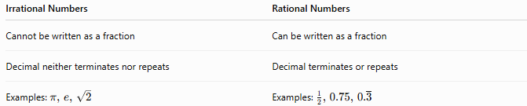
Irrational Numbers | Rational Numbers
Cannot be written as a fraction | Can be written as a fraction
Decimal neither terminates nor repeats | Decimal terminates or repeats
Examples: $π, e, \sqrt{2}$ | Examples: $\frac{1}{2}, 0.75, 0.\overset{‾}{3}$

Irrational Numbers vs. Real Numbers
# Source: AI Source: Provided by: [Data Path: Persons Table -> ID Column: 1, Name_En Column: Motasem Essam] -> From: [ChatGPT] on [7/15/2026]
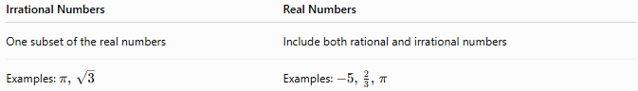
Irrational Numbers | Real Numbers
One subset of the real numbers | Include both rational and irrational numbers
Examples: $π, \sqrt{3}$ | Examples: $-5, \frac{2}{3}, π$

Irrational Numbers vs. Complex Numbers
# Source: AI Source: Provided by: [Data Path: Persons Table -> ID Column: 1, Name_En Column: Motasem Essam] -> From: [ChatGPT] on [7/15/2026]
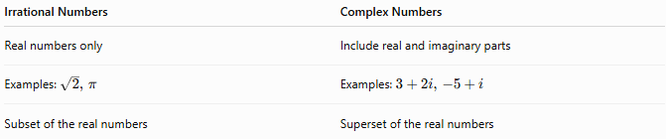
Irrational Numbers | Complex Numbers
Real numbers only | Include real and imaginary parts
Examples: $\sqrt{2}, π$ | Examples: $3+2i, -5+i$
Subset of the real numbers | Superset of the real numbers

Conclusion
# Source: AI Source: Provided by: [Data Path: Persons Table -> ID Column: 1, Name_En Column: Motasem Essam] -> From: [ChatGPT] on [7/15/2026]
The Irrational Numbers Set consists of all real numbers that cannot be expressed as the quotient of two integers. It is most accurately represented as
$$R∖Q,$$
the set of real numbers excluding the rational numbers. Irrational numbers have decimal expansions that are infinite, non-terminating, and non-repeating, and include important constants such as $π$, $e$, $\sqrt{2}$, and the Golden Ratio $ϕ$. Together with the rational numbers, they make up the complete set of real numbers and play an essential role throughout mathematics, science, engineering, and technology.

